**DESIGN IS DESIGN IS DESIGN**

Instructor: Joe Natoli

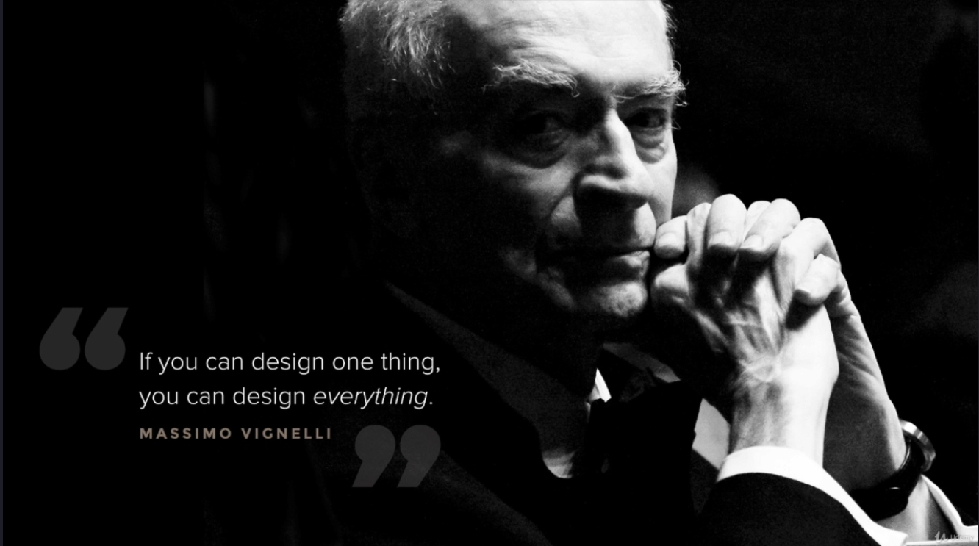

* treat design like a problem solving discipline which stems from human behaviours and reactions.
* The same principles have guided designs for hundreds of years
* 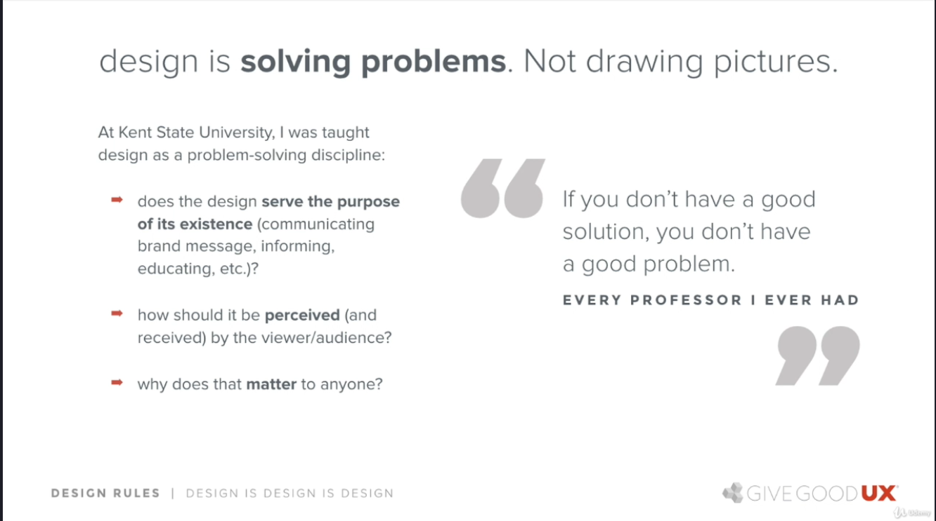if you don’t have a good solution(design), that means you haven’t spent enough time figuring what you’re hoping to accomplish with your design
* if design was just suppose to look good, that will be decoration, not design
* 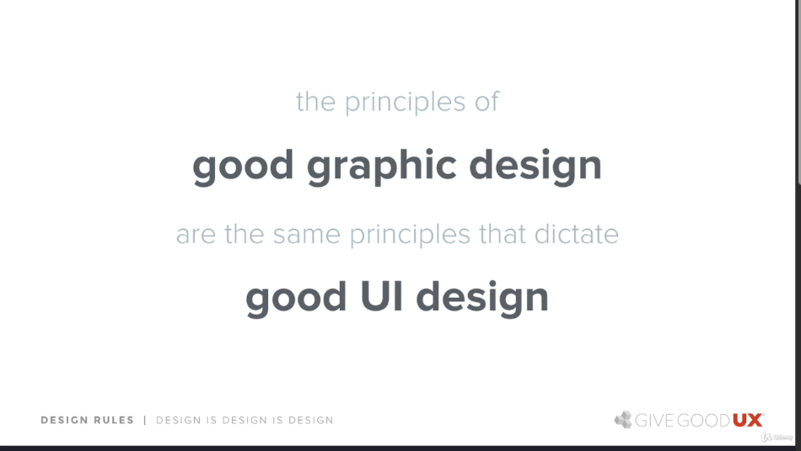all design are based on the same principles
* colour schemes are on purpose they have meaning. Lower case most times symobolizes human, friendliness, ease. Fonts have feel and meaning; slants and italization most times suggest movement, all visual representations should be purposeful, and all illustriation also have meaning
* 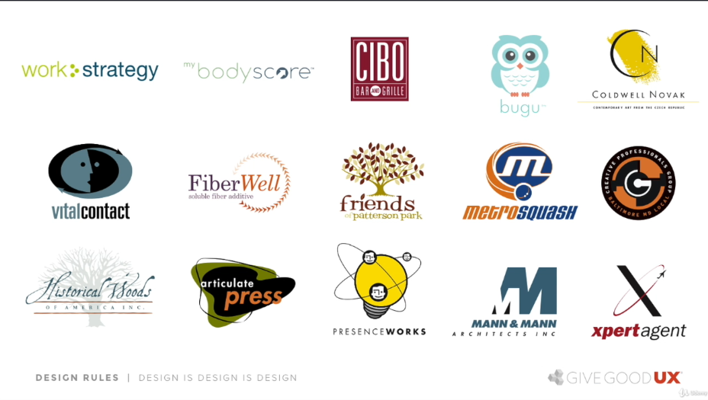
* All the visual decisions in the above logos are all purposeful, there were all chosen on purpose
* There has to be purpose in the visual decisions we make, and that holds true for all design
* Think of what you wanna convey, and think of how you wanna convey that, the logo, the colour, etc, while making sure the design is unique to that brand
* Make things visually interesting enough to feel interactive, enough to keep eyes moving, and keeping engagement with the content
* In a digital age static design is viewed as boring
* color, contrast and typography affects the emotion of a design
* you can get all the colour for your design from the different colors in the photograph, everything in UI design is purposeful, nothing is wasted, even color
* The little details matter, and how and why they are the way they are matters a whole lot more, as wasteful design wouldn’t most times promote engagement
* the size in the graphics, the organization, the relation, colour, even the hierarchy of the colour scheme all matter
* everything in design is based on cognitive response, how it will be received, why they’d react to what they see, and in what order they would
* When things touch there’s tension, and it draws attention
* 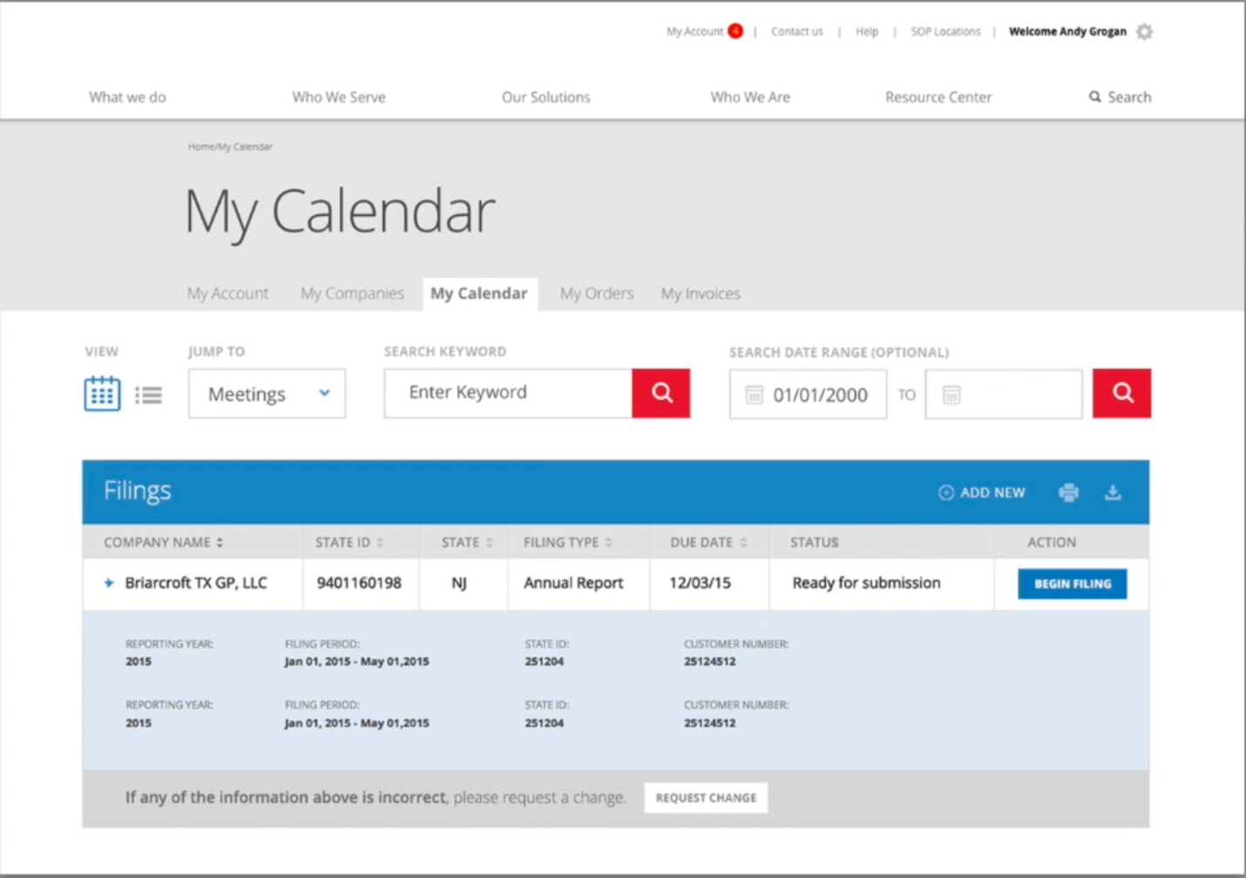
  + this design is data heavy, and as such it needed a clean airy feel, with only a few colours drawing attention to what mattered, as well as the colour hierarchy in relation to what needed most attention
* **Design mantra 01: design is design is design**